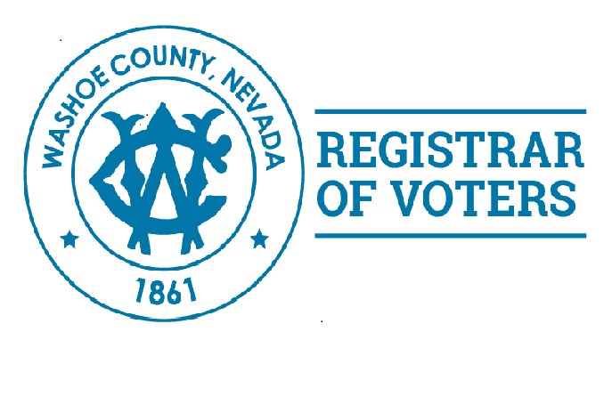

Dear Parent(s)/Guardian(s):

The Washoe County Registrar of Voter’s Office encourages interested high school students to become involved in the election process. One of the ways to do this is for students to work at a polling location on Election Day as a Poll Worker.

Students are given the opportunity to work as a team with three or four other Poll Workers which will give them a unique and beneficial experience that they will carry with them throughout their lives. Each polling place team is a mix of adult poll workers who are experienced Election Day workers and those who are working as a poll worker for the first time.

Your young adult will benefit from this program in several ways:

* Hands-on experience learning how local elections are conducted
* Receive training on how to open a polling place, process voters and close the polls
* Inspire them to vote when they reach 18 years of age
* Gain a lifelong appreciation for the electoral process

Working an election means being prepared for a very long day. The student is expected to be at the polling place on Election Day at 5:30 a.m. and may be required to work as late as 9 p.m. Students are responsible for providing their own transportation to and from the polling place. A student’s assigned polling place will be as close to their home as possible. Students are paid the same stipend amount as other polling place workers. Stipend checks are mailed 2 to 3 weeks following the election.

Interested students must be:

* at least 16 years of age
* a US Citizen
* a resident of the County in which they wish to be a poll worker

Students wishing to work during an election must also:

* Receive written permission from their parent(s) or legal Guardian(s)
* Attend the required 2 to 3 hour In-Person training class and help setup on “Election Eve”
* Complete all required On-Line training

To be considered for this program, your child must complete a single page online Election Poll Worker application, a parent/guardian consent form, and a school consent form.

Please do not hesitate to call (775) 328-3695 should you have any questions.

Sincerely,

Jon Brown

Poll Worker Recruiter

[jobrown@washoecounty.us](mailto:jobrown@washoecounty.us)







**Student Pollworker Permission Form**

***Students must be at least 16 years old to apply.***

Parental Consent

I, _______________________________ hereby grant ________________________________ my

(Name of Parent/Guardian) (Name of Student)

permission to work as a Poll Worker during the ___________________________election.

(Date of Election)

Student’s Address: ____________________________ Student’s Telephone Number: ___________

____________________________

__________________________________________ ___________________

Signature of Parent or Guardian Date

**School Consent**

I ___________________________________hereby grant permission to the above named student to

Name of Principal or Guidance Counselor)

work as a Poll Worker during the ________________________election.

(Date of Election)

______________________________________________________

Name of School and School District

______________________________________________________ ________________

Signature of School Representative and Title Date

